Navigate to the Ohio Shared Services website at www.ohiosharedservices.ohio.gov/
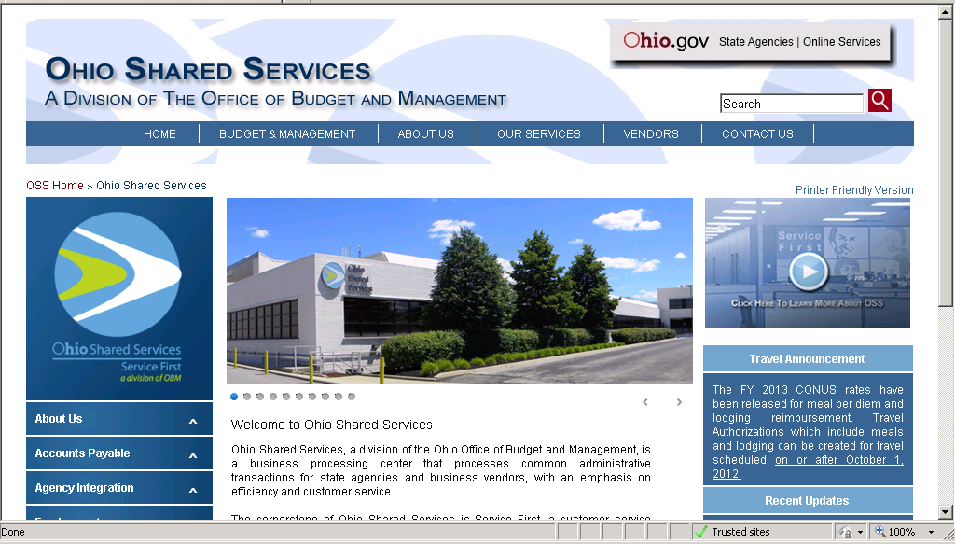

Scroll down the left navigation menu to Vendor Maintenance
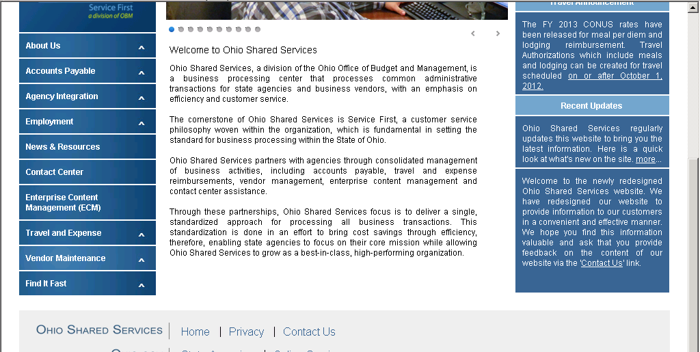

Next select ‘Vendor Forms’
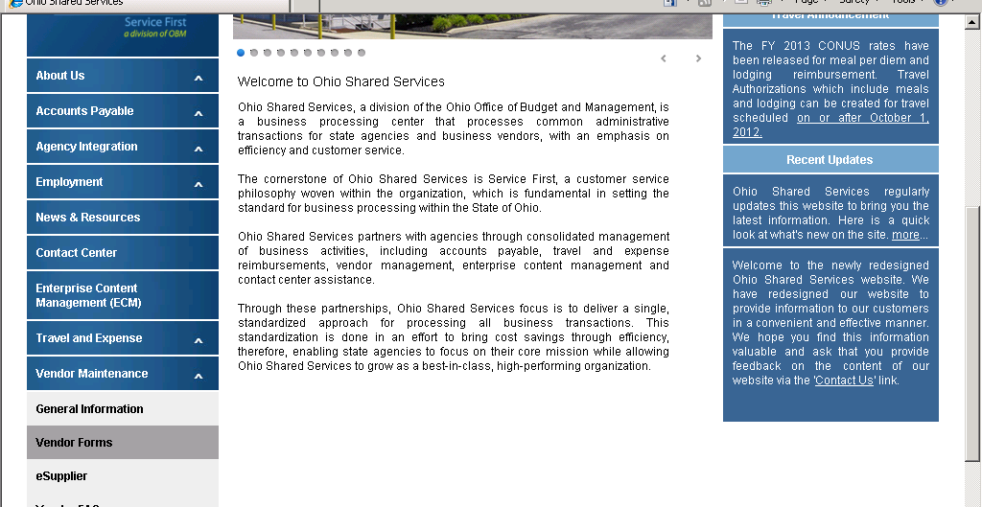
Select the Vendor Information form (OBM 5657)
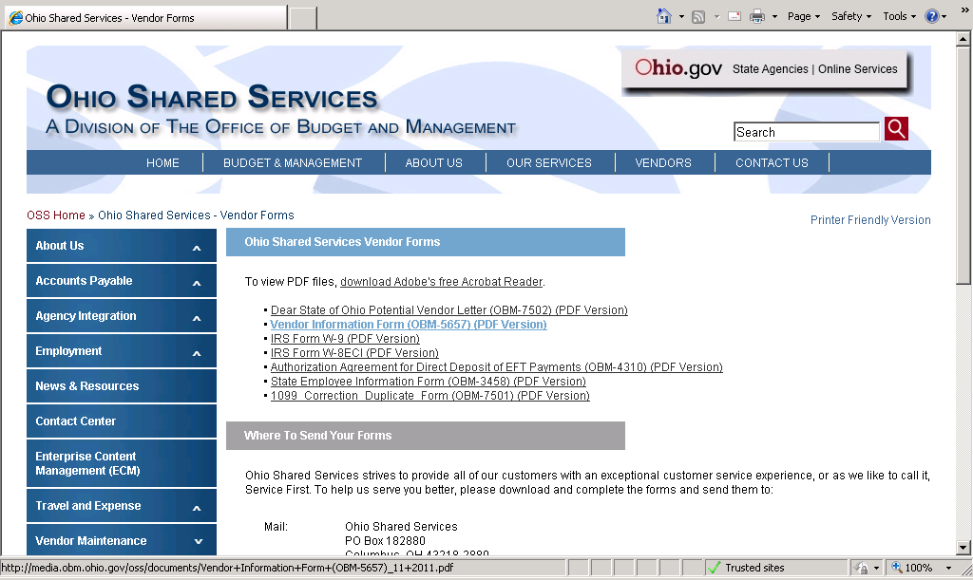

Complete the form and submit it to address indicated on the form.
